4/22/22 11:00 pm – 4/23/2022 1am (~40min of work) ~3 conscious decisions and 20 min of actual work

Renamed and basic setup

Wathcing

<http://cse.csusb.edu/tongyu/courses/cs460/notes/intro.php>

* **best OS example/explaination**
  + <https://www.youtube.com/watch?v=z4LEuxMGGs8&t=324s&ab_channel=FooSo>

read assignment x1

bash

<https://www.youtube.com/watch?v=I4EWvMFj37g&ab_channel=Fireship>

* Watch Later
  + <https://www.youtube.com/watch?v=oxuRxtrO2Ag&ab_channel=JoeCollins>

Created a simple flowchart

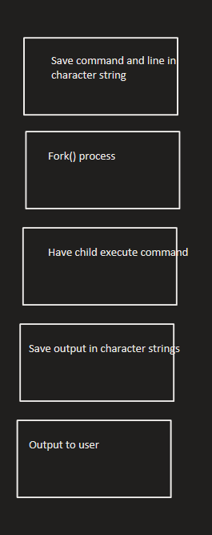

4/26/22 6:30a – 7:00a

Boot issues.

7:00 – 8:08am

Used Gio’s for exec.c and prog4.c to help post

Next steps?

* Go through code.
  + Learn what each of the dup2, open, close, etc. do
  + Iterate through
* Create a flowchart
* Recreate the project from scratch